

SUPERVISED ON-THE-JOB TRAINING WAIVER CERTIFICATION

TO WHOM IT MAY CONCERN:

This is to certify that I, ADELFA R. BORRES, parent/ guardian of JEJY M. BORRES, a student of the School of Engineering Technology, MSU- Iligan Institute of Technology, Iligan City, granted the student permission to undergo On-the-Job Training at FemoNova Health, UP Cebu Business Incubator for IT, University of the Philippines, Cebu Gorordo Avenue, Lahug, Cebu City 6000 Philippines from June 2024 to August 2024.

I understand and agree that this training is a necessary requirement for the completion of the Bachelor of Science in Computer Engineering in the said School.

I also affirm that the Company and the School are in no way responsible nor financially liable for any accident, harm, or injury that the student may experience during the course of the training.

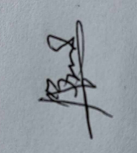I further certify that on our own free will I allow the student and the student signified to undergo this On-the-Job Training Program as evidenced by our affixed signatures.

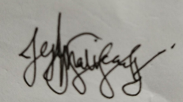

JEJY M. BORRES ADELFA R. BORRES

Name and Signature of Trainee Name and Signature of Parent/Guardian Witnesses:

Signature Over Printed Name Signature Over Printed Name

Republic of the Philippines) Iligan City )

x )

SUBSCRIBED AND SWORN before me this day of , 2024 at Iligan City, Philippines.

WITNESS MY HAND AND SEAL on the date and place written above.

NOTARY PUBLIC

Doc. No. Page No. Book No. Series of

